CHECK ME- AN OBJECT DETECTION APP


By

Ayesha Adnan F22NDOCS1M01093

Supervisor
Mr. Shahid Hussain

Bachelor of Science in Computer Science (2022-2026)

The Islamia University of Bahawalpur
Bahawalnagar Campus
Fall 2022

The Islamia University of Bahawalpur
Bahawalnagar Campus

CHECK ME- AN OBJECT DETECTION APP

A project presented to

The Islamia University of Bahawalpur, Bahawalnagar Campus

In partial fulfillment
Of the requirement for the degree of

Bachelor of Science in Computer Science (2022-2026)

By

Ayesha Adnan F22NDOCS1M01093

DECLARATION

We hereby declare that this software, neither whole nor as a part has been copied out for many source. It is further declared that we have developed this software and accompanied report entirely on the basis of our personal efforts. If any part of this project is proved to be copied out from any source or found to be reproduction of some other. We will stand by the consequences. No Portion of the work presented has been submitted of any application for any other degree or qualification of this or any other university or institute of learning.

Student Name

CERTIFICATE OF APPROVAL

It is to certify that the final year project of BS (CS) “Object Detection App” was developed by AYESHA ADNAN (F22NDOCS1MO01093 under the supervision of “MR SHAHID HUSSAIN” and co supervisor “CO-SUPERVISOR NAME” and that in (their/his/her) opinion; It is fully adequate, in scope and quality for the degree of
Bachelors of Science in Computer Sciences.

Supervisor

External Examiner

Head of Department
(Department of Computer Science)

Executive Summary

In public places, there is often a need for monitoring people and different activities going on, which can be referred later for many reasons including security. Appointing humans for this task involves many problems such as increased employee hiring, accuracy problem, trust, no proof for later use, and also the fact that a human can remember things till a certain time limit. Talking about the current security system, they use dumb still cameras with a continuous recording facility ir-respective of the fact that any event may happen or not. Moreover they are usually pointing at a specific user defined locations so more than one camera are required to cover the entire region.

To prevent all these problems from prevailing, the CSCS is developed. It is a surveillance system, which provides solution to many of these problems. It is a stand-alone applicationwhichdoesn‟trequireanycomputertooperate.Itmonitorsdifferentsituationsusingacamerawhich is able to rotate intelligently based on sensor messages and captures the scene in the form of video or photos later reference as well.

Customizable Surveillance Control System (CSCS) is a surveillance system that can be assigned a sensor type as in our case a heat sensor is used, it works accordingly, rotates the camera upon event detection and perform user defined actions like capturing video and store them, for the future use.

It is an embedded system consisting of Linux fox kit with embedded a running server application also a camera, USB storage device and a sensor node base station is attached with fox kit. LAN communication is used by user to download the videos and to operate the system manually.

Acknowledgement

All praise is to Almighty Allah who bestowed upon us a minute portion of His boundless knowledge by virtue of which we were able to accomplish this challenging task.

We are greatly indebted to our project supervisor “Mr. Shahid Hussain” and our Co-Supervisor “Mr. Mukhtar Azeem”. Without their personal supervision, advice and valuable guidance, completion of this project would have been doubtful. We are deeply indebted to them for their encouragement and continual help during this work.

And we are also thankful to our parents and family who has been a constant source of encouragement for us and brought us the values of honesty & hard work.

Student Name 1 Student Name 2

Student Name 3

Abbreviations

SRS | Software Require Specification
PC | Personal Computer

Table of Contents
- Introduction 1
  - Brief 2
  - Relevance to Course Modules 2
  - Project Background 3
  - Literature Review 4
  - Analysis from Literature Review(in the context of your project) 4
  - Methodology and Software Life cycle for This Project 4
    - Rationale behind Selected Methodology 5
- Problem Definition 6
  - Problem Statement 7
  - Deliverables and Development Requirements 7
  - Current System (if applicable to your project) 8
- Requirement Analysis 12
  - Use Cases Diagram(s) 13
  - Detailed Use Case 17
  - Functional Requirements 24
  - Non-Functional Requirements 25
- Design and Architecture 35
  - System Architecture 36
  - Data Representation [Diagram + Description] 39
  - Process Flow/Representation 40
  - Design Models [along with descriptions] 44
- Implementation 51
  - Algorithm 52
  - External APIs 54
  - User Interface 55
- Testing and Evaluation 60
  - Manual Testing 61
    - System testing 61
    - Unit Testing 68
    - Functional Testing 69
    - Integration Testing 70
  - Automated Testing 71
Tools used: 71
- Conclusion and Future Work 72
  - Conclusion 73
  - Future Work 74
- References 75

List of Figures

Figure2.3.1 Snapshots of frontend………....………………………………………………………………9
Figure2.3.2………………………………………………………………………………………………..10
Figure2.3.3………………………………………………………………………………………………..11
Figure3.1 System level use-case………………………………………………………………………….13
Figure3.1.1 Use-case1…………………………………………………………………………………….14
Figure3.1.2 Use-case2…………………………………………………………………………………….14
Figure3.1.3 Use-case3…………………………………………………………………………………….15
Figure3.1.4 Use-case4…………………………………………………………………………………….15
Figure3.1.5 Use-case5…………………………………………………………………………………….16
Figure4.1 System Architecture………........................................................................................................36
Figure4.2 Data Representation……………………………………………………………………………39
Figure4.3.1 Level 0……………………………………………………………………………………….41
Figure4.3.2 Level 1……………………………………………………………………………………….42
Figure4.3.3 Level 2……………………………………………………………………………………….43
Figure4.4.1 Class Diagram………………………………………………………………………………..44
Figure4.4.2 Sequence Diagram…………………………………………………………………………...45
Figure4.4.3 Flow Message………………………………………………………………………………..48
Figure4.4.4 State Transition………………………………………………………………………………48
Figure4.4.5 Data Flow…………………………………………………………………………………….49
Figure4.4.6 Schematic Diagram…………………………………………………………………………..49
Figure4.4.7 Timing Diagram……………………………………………………………………………...50

List of Tables

Table3.2.1………………………………………………………………….……………………………..19
Table3.2.2………………………………………………………………………………………………...20
Table3.2.3………………………………………………………………………………………………...21
Table3.2.4………………………………………………………………………………………………...22
Table3.2.5………………………………………………………………………………………………...23
Table3.3.1………………………………………………………………………………………………...24
Table3.3.2………………………………………………………………………………………………...24
Table3.3.3………………………………………………………………………………………………...25
Table3.5.1………………………………………………………………………………………………...26
Table5.2…………………………………………………………………………………………………..54

1

Introduction

This chapter provides an overview of the project and explains the background, motivation, and methodology used for the development of the system. It highlights the relevance of the project with the academic course work and provides a brief discussion of related research and technologies used in object detection systems.

1.1: Brief
The rapid advancement in computer vision and artificial intelligence has enabled machines to interpret and understand visual data more effectively. Object detection is a key area of computer vision that allows systems to identify and locate objects within images or video streams. The purpose of this project is to develop an Object Detection Application capable of recognizing and detecting different objects in real time using machine learning techniques.
The proposed system uses modern computer vision techniques and trained models to detect objects through a camera or image input. The system processes the visual data, identifies objects, and provides accurate detection results. This application can be useful in various domains such as surveillance systems, automated monitoring, smart environments, and assistive technologies.
The development of this project involved the use of programming languages, machine learning frameworks, and computer vision libraries to build a reliable object detection system. Different methodologies and tools were used during the development process to ensure efficiency and accuracy. The following chapters discuss the requirements, design, implementation, testing, and evaluation of the developed system.

1.2: Relevance to Course Modules
This project integrates knowledge and concepts learned during the Bachelor of Science in Computer Science program. Several course modules contribute directly to the development of this project.
Courses related to Artificial Intelligence and Machine Learning provides the fundamental understanding of algorithms used in object detection and classification. Data Structures and Algorithms help in efficient processing and management of data used in the system. Knowledge from Software Engineering assists in following structured development methodologies such as requirement analysis, system design, and testing.
Additionally, Computer Vision and Image Processing concepts are applied to process images and detect objects accurately. Programming knowledge gained through courses such as Programming Fundamentals, Object Oriented Programming, and Software Development enables the implementation of the application. Therefore, this project reflects the practical application of multiple academic concepts studied during the degree program.

1.3: Project Background

1.3.1: Existing Systems
Currently, there are limited options available for users to identify objects in images or captured using a camera. Some existing systems rely on manual input or keyword-based searches, which can be time-consuming and prone to errors. Other systems utilize pre-defined object recognition models but lack flexibility and accuracy in identifying a wide range of objects. These limitations highlight the need for an advanced and user-friendly solution like the Check-Me app.

1.3.2: Drawbacks
The drawbacks of existing systems include the reliance on manual input, which is labor-intensive and inefficient. Keyword-based searches may not provide accurate results, especially for complex or less common objects.
Additionally, pre-defined object recognition models often struggle with real-time identification and fail to adapt to varying environmental conditions. These drawbacks hinder users' ability to quickly and accurately gather information about objects, limiting their overall experience and productivity. The Check-Me app aims to address these drawbacks by utilizing machine learning techniques and providing a seamless user experience.

1.3.3: Proposed Solution
The Check-Me app aims to provide a user-friendly and efficient solution for identifying objects in images or captured using a camera. It utilizes image/object detection techniques powered by machine learning to provide users with accurate and relevant information about objects in real time.
Here's how Check-Me solves the identified problem:
- The app utilizes a simple and intuitive interface that allows users to capture images or select existing ones for object identification easily.
- Check-Me uses a machine learning model that is already used in the market based on vast datasets of images and objects. This enables the app to recognize a wide range of objects with high accuracy.
- The app is designed to function even without an internet connection ultimately which allows users to identify objects on the go, regardless of their location or network availability.
- Check-Me is designed to be compatible with various devices, ensuring accessibility for a broad user base.

1.4: Literature Review

Several research studies and applications have been developed in the field of object detection and computer vision. Modern object detection systems rely heavily on deep learning models and advanced algorithms.

Researchers have developed various techniques such as Region-Based Convolution Neural Networks (R-CNN), Fast R-CNN, Faster R-CNN, and YOLO (You Only Look Once) for object detection tasks. These models have significantly improved the speed and accuracy of detecting objects within images and videos.

YOLO-based models are particularly popular due to their ability to perform real-time object detection with high accuracy. They divide images into grids and predict bounding boxes and class probabilities simultaneously. This approach makes them suitable for applications requiring fast and efficient detection.
Many existing systems utilize these technologies in areas such as smart surveillance systems, automated traffic monitoring, security systems, and industrial automation.

1.5: Analysis from Literature Review (in the context of your project)
Based on the literature review, it is evident that deep learning-based object detection techniques provide higher accuracy and efficiency compared to traditional approaches. Modern systems focus on real-time detection and automation to improve performance and reduce human effort.
The analysis of existing solutions highlights the importance of using optimized algorithms and reliable frameworks to achieve accurate detection results. The proposed project adopts similar principles by implementing a machine learning-based object detection model capable of detecting objects in real time.
By integrating computer vision techniques with modern programming tools, the project aims to develop a system that demonstrates the practical implementation of object detection technology.

1.6: Methodology and Software Lifecycle for This Project

The development of the object detection application follows a structured software development lifecycle to ensure systematic progress and quality results. The project includes phases such as requirement analysis, system design, implementation, testing, and evaluation.

During the requirement analysis phase, system requirements are identified and documented. In the design phase, system architecture and design models are created to represent the structure of the system. The implementation phase involves developing the application using appropriate programming tools and frameworks.

After implementation, the system undergoes testing and evaluation to ensure that it functions correctly and meets the defined requirements. This methodology helps in maintaining a well-organized development process.
1.6.1: Rationale behind Selected Methodology
A structured methodology is selected for this project to ensure efficient development and proper documentation of each stage. The use of a systematic software development lifecycle helps in managing the project effectively and identifying potential issues early in the development process.

By following a clear methodology, the development team can maintain proper coordination between requirement analysis, design, implementation, and testing phases. This approach improves the overall quality, reliability, and maintainability of the developed system.

2

Problem Definition

2.1: Problem Statement

In the modern digital era, visual data such as images are generated in large quantities through cameras, smart phones, and surveillance systems. Analyzing and identifying objects within this visual information manually is a complex and time-consuming task. Traditional monitoring systems often depend on human observation to detect and recognize objects, which can lead to errors, inefficiency, and delayed responses.

In many practical applications such as security surveillance, traffic monitoring, smart cities, and automated systems, it is important to quickly identify objects present in an image or video stream. However, many existing systems lack the capability to automatically analyze visual data and accurately detect objects in real time. This limitation increases the workload on human operators and reduces the overall efficiency of monitoring and analysis processes.

Another challenge is that traditional image processing techniques often rely on manual feature extraction and simple algorithms, which may not provide accurate results in complex environments. Variations in lighting conditions, object sizes, and backgrounds can further reduce the accuracy of these systems. As a result, there is a need for intelligent systems that can automatically learn from data and detect objects with higher accuracy.

To address these challenges, this project proposes the development of an Object Detection Application that uses modern computer vision and machine learning techniques to identify objects from images or live camera input. The system will automatically analyze the visual data, detect objects present in the scene, and display the results to the user in an understandable format.
The goal of this project is to design and implement a system that can perform object detection efficiently. By automating the process of object identification, the proposed system aims to reduce human effort, improve accuracy, and provide a practical solution for object recognition tasks.

2.2: Deliverables and Development Requirements

The primary deliverable of this project is a fully functional Object Detection Application capable of detecting and identifying objects from images or live camera input. The system will use computer vision and machine learning techniques to analyze visual data and automatically recognize objects present in the scene. The application will provide users with an interface through which they can view the detected objects and interact with the system easily.

The system will process input data from images or a camera feed and apply object detection algorithms to identify different objects. Once an object is detected, the system will display the results by highlighting the detected objects with bounding boxes and labels. This will help users clearly understand what objects are present in the image.

The major deliverables of the project include:
- A complete Object Detection App capable of identifying objects from images or real-time camera input.
- Implementation of computer vision and machine learning techniques for accurate object detection.
- A user-friendly interface that allows users to run the application and view detection results easily.
- A system that displays detected objects with labels and bounding boxes for better visualization.
- Complete project documentation, including Software Requirements Specification (SRS), Software Design Description (SDD), and the final project report.
In addition to the software application, proper documentation will be provided to describe the system requirements, system design, implementation process, and testing procedures. This documentation will help explain the working of the system and provide guidance for future improvements or further development.

The development of this project requires the use of appropriate programming tools, development environments, and libraries related to computer vision and machine learning. The application will be developed using suitable programming languages and frameworks to ensure efficiency, reliability, and accuracy in object detection.

2.3: Current System (if applicable to your project)

Currently, many systems that involve monitoring or analyzing visual information rely heavily on manual observation. In traditional environments such as security surveillance or monitoring systems, cameras are used to capture video streams, but the responsibility of identifying objects or suspicious activities usually falls on human operators. This process requires continuous attention and can become inefficient when large amounts of visual data need to be monitored.

Manual monitoring systems also increase the chances of human error. When operators are required to observe multiple camera feeds or analyze large numbers of images, it becomes difficult to maintain consistent accuracy. Important details may be overlooked, especially in situations where quick responses are required. As a result, relying solely on human observation is not always practical for modern applications.

Some existing systems attempt to use basic image processing techniques to identify objects. However, these systems often depend on simple algorithms and manually defined features, which limits their effectiveness in complex environments. Changes in lighting conditions, background variations, object movement, and differences in object shapes or sizes can significantly reduce the accuracy of traditional methods.

Furthermore, many advanced object detection solutions available today require expensive hardware, complex configurations, or specialized technical knowledge to operate effectively. This makes them less accessible for smaller applications or educational projects.
The proposed Object Detection App aims to address these limitations by introducing an automated system capable of detecting objects using computer vision and machine learning techniques. Instead of relying entirely on manual observation, the system will automatically analyze images or live cameras input and identify objects present in the scene. By doing so, the system will improve efficiency, reduce human effort, and demonstrate the potential of intelligent technologies in solving real-world problems related to visual data analysis.

Snapshots of Frond End
Form Title: Start Screen
Interface Id: | UI – 01
Description: | The Start Screen of Check Me provides initial app navigation options for users, facilitating seamless entry into the application's functionality.
Snapshot:
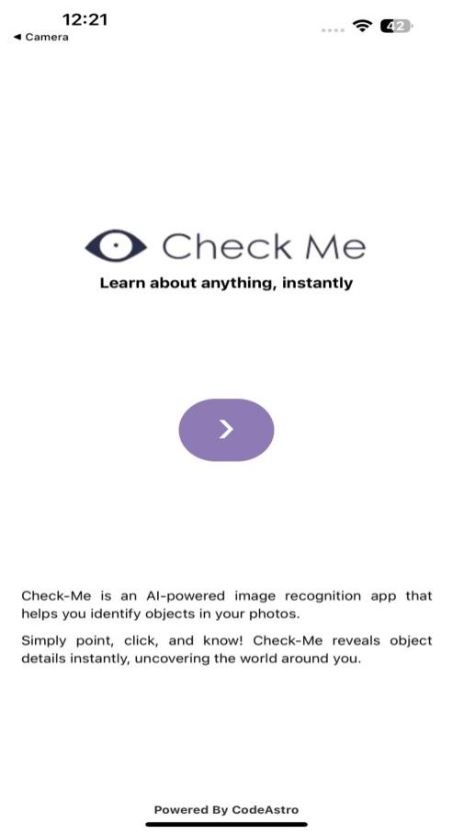

Figure 2.3.1

Form Title: Home Screen
Interface Id: | UI – 02
Description: | The Home screen of Check Me serves as the central hub where users can either capture images using their device's camera or upload images from their gallery for object detection. It provides seamless navigation options to initiate image processing and view detection results efficiently..
Snapshot:
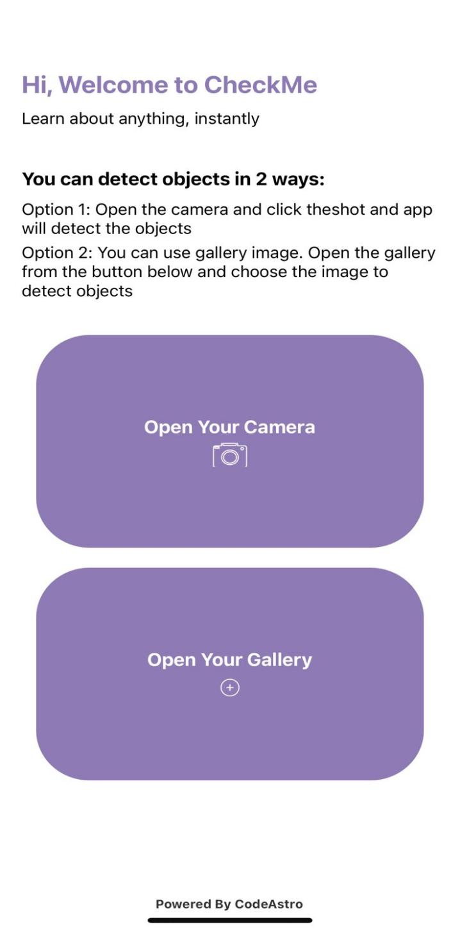
Figure: 3.2.2

Form Title: Result Screen
Interface Id: | UI – 03
Description: | The Result screen in Check Me displays annotated images with detected objects and their names after performing object detection on uploaded or captured images.
Snapshot:
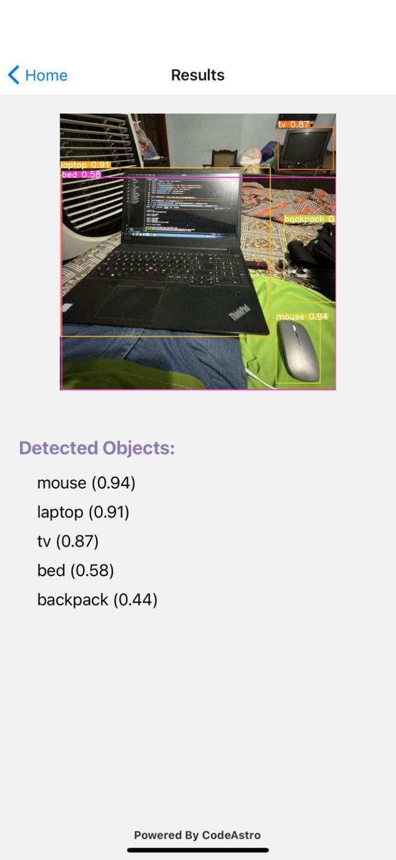

Figure: 3.2.3

3

Requirement Analysis

3.1: Use Case Diagram(s)

Use Case Diagram

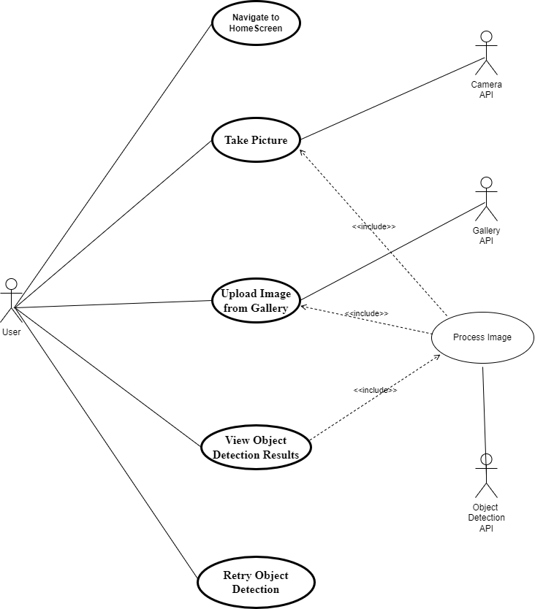

Figure 3.1: System Level Use Case Diagram

Use Case-1:

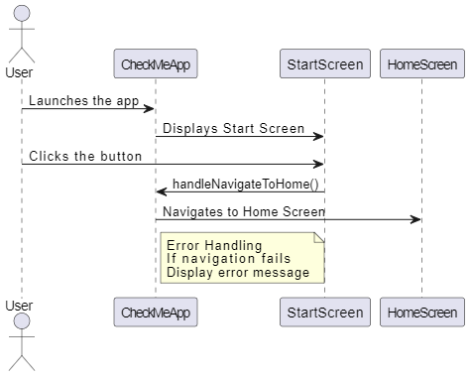

Figure 3.1.1: Navigate to Home Screen

Use Case-2:

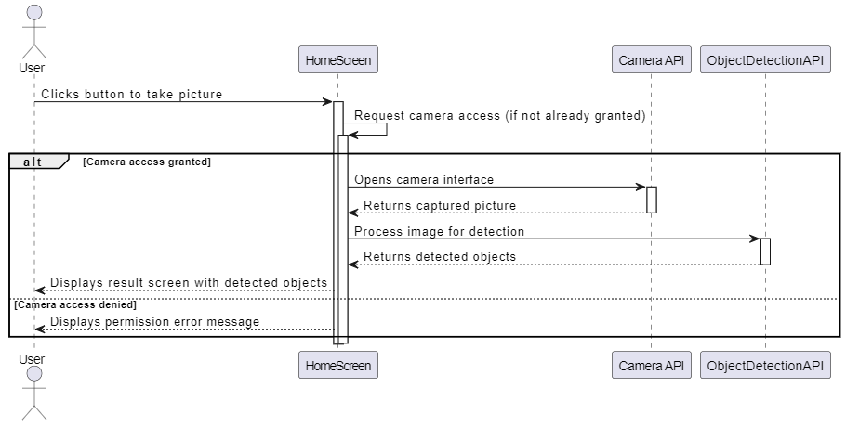

Figure 3.1.2: Take Picture

Use Case-3:

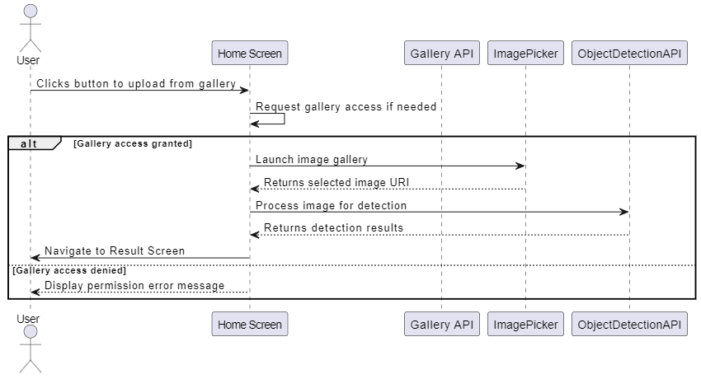

Figure 3.1.3: Upload Image from Gallery

Use Case-4:

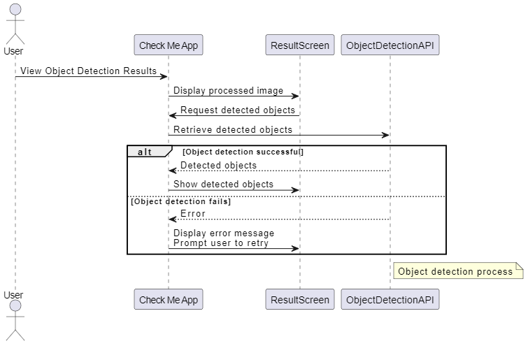

Figure 3.1.4: View Object Detection Results

Use Case-5:

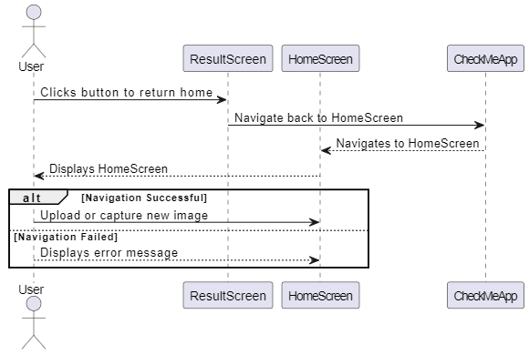

Figure 3.1.5: Retry Object Detection

3.2: Detailed Use Cases

Use Case 1:
Use Case: Navigate to Home Screen
Description: This use case describes the process of a user navigating from the Start Screen to the Home Screen.
Actors: User
Stake holders: User, System
Pre condition: The app is installed and launched on the user’s device.
Main Flow:
- User launches the app.
- The Start Screen is displayed.
- User clicks the button on the Start Screen.
- The app navigates to the Home Screen.

Alternate Flow:
If the app fails to navigate to the Home Screen, an error message is displayed.
Post condition: The user is on the Home Screen and can proceed with further actions.

Use Case 2:
Use Case: Take Picture
Description: This use case outlines the process of a user capturing a picture using the device's camera for object detection.
Actors: User, Camera API
Stake holders: User, System
Pre condition: The user is on the Home Screen, and the app has permission to access the camera.
Main Flow:
- User clicks the button to take a picture.
- The app requests camera access if not already granted.
- The Camera API opens the camera interface.
- User captures a picture.
- The app processes the image for object detection.
Alternate Flow:
If the user denies camera access, the app displays a permission error message.
Post condition: The captured image is processed for object detection.

Use Case 3:
Use Case: Upload Image from Gallery
Description: This use case describes the process of a user uploading an image from the device's gallery for object detection.
Actors: User, Gallery API
Stake holders: User, System
Pre condition: The user is on the Home Screen, and the app has permission to access the gallery.
Main Flow:
- User clicks the button to upload an image from the gallery.
- The app requests gallery access if not already granted.
- The Gallery API opens the gallery interface.
- User selects an image.
- The app processes the image for object detection.
Alternate Flow:
If the user denies gallery access, the app displays a permission error message.
Post condition: The uploaded image is processed for object detection.

Use Case 4:
Use Case: View Object Detection Results
Description: This use case outlines the process of a user viewing the results of the object detection.
Actors: User, Object Detection API
Stake holders: User, System
Pre condition: An image has been captured or uploaded and processed for object detection.
Main Flow:
- The app displays the processed image on the Result Screen.
- The app shows the detected objects annotated on the image.
- The app lists the names of detected objects below the image.
Alternate Flow:
If the object detection fails, the app displays an error message and prompts the user to retry.
Post condition: The user views the detected objects and their names on the Result Screen.

Use Case 5:
Use Case: Retry Object Detection
Description: This use case describes the process of a user returning to the Home Screen to perform object detection on a new image.
Actors: User
Stake holders: User, System
Pre condition: The user is on the Result Screen and has viewed the object detection results.
Main Flow:
- User clicks the button to return to the Home Screen.
- The app navigates back to the Home Screen.
Alternate Flow:
If the navigation fails, an error message is displayed.
Post condition: The user is on the Home Screen and can upload or capture a new image for detection.

USE CASE DESCERIPTION
The primary use case for the Check-Me application is Detect Object in Image (UC-1).

Use Case-1: Navigate to Home Screen

Use Case Name | Navigate to Home Screen
Actors | Primary Actor: User  Supporting Actors: System UI Manager
  Description
  This use case defines how a user launches the Check-Me app and navigates from the Start Screen to the Home Screen. The Home Screen serves as the primary functional hub where the user can choose to capture a new image or upload one from the gallery.
Trigger
  The user taps the “Get Started” or navigation button on the Start Screen.
 | 1. App is successfully installed on the device.  2. App launches without crashing.  3. Device has sufficient memory to run UI components.  4. Start Screen UI elements are loaded.
  Pre-conditions
  Post-conditions
  1.User is successfully redirected to the Home Screen.
  2. Camera and gallery buttons are available for interaction.
  3. App prepares system resources for next actions (e.g., model load preparation).
 | 1. User launches the app.  2. Start screen appears.  3. User taps the navigation button.  4. App navigates to Home Screen.
  Normal Flow
 | Internet is not required for this use case; system behaves normally even without connectivity.
  Alternative Flow [Not in Network]
Exceptions | E1: UI Load Failure — Start Screen components fail → System shows “Loading Error.”  E2: Touch Not Responding — Button fails to register touch → Prompt user to restart application.  E3: App Freezes — System terminates use case and reloads Start Screen.
Business Rules | BR-1: Home Screen must load within 2 seconds.  BR-2: Button labels must comply with accessibility guidelines.  BR-3: Navigation transitions must follow approved UI flow.
 | 1. Device is functioning normally.  2. User understands basic mobile navigation.  3. There is no OS-level restriction on app UI rendering.
  Assumptions
Table 3.2.1: Navigate to Home Screen

Use Case-2: Take Picture

Use Case Name | Take Picture
Actors | Primary Actor: User  Supporting Actors: Camera API, Device Hardware (Camera Module)
  Description
  This use case describes how the user activates the camera from within the Check-Me app, captures an image, and sends that image to the detection pipeline. The process involves device permission checks, camera activation, image acquisition, and transfer to the detection module.
Trigger
  User taps the “Take Picture” button on the Home Screen.
  Pre-conditions
  1. User is on Home Screen.
  2. Camera permission is granted.
  3. Device camera is functional.
  4. Adequate lighting is available for image capture.
  5. Device storage is available for saving a temporary image.
  Post-conditions
  1. A valid captured image is forwarded to the object detection module.
  2. Image preview is displayed.
  3. App transitions to “Processing/Analyzing” state.
  Normal Flow
  1. User taps “Take Picture”.
  2. App checks camera permission.
  3. Camera API opens camera.
  4. User captures image.
  5. App receives image and starts processing.
 | 1. App detects no network.  2. App continues offline because detection does not need internet.  3. Continue normal flow.
  Alternative Flow [Not in Network]
Exceptions
  E1: User denies camera permission → Show permission error.
  E2: Camera fails to open → Show camera error.
Business Rules | BR-1: Camera access must always be requested securely.
 | Device camera works properly.
  Assumptions

Table 3.2.2: Take Picture

Use Case-3: Upload Image from Gallery

Use Case Name | Upload Image from Gallery
Actors | Primary Actor: User  Supporting Actors: Gallery API, File System
  Description
  The user chooses an existing image from the device’s gallery. The app requests gallery permission, opens the image selection interface, loads the selected image, verifies format compatibility, and sends image to the detection module.
Trigger
  User taps the “Upload Image” button.
  Pre-conditions
  1. User is on Home Screen.
  2. Gallery permission is granted.
  3. Device storage is accessible.
  4. Image formats are supported (JPG/PNG).
  Post-conditions
  1. A valid uploaded image is loaded in the preview screen.
  2. Image is forwarded to the detection module.
  Normal Flow
  1. User taps “Upload Image”.
  2. App checks gallery permission.
  3. Gallery API opens image picker.
  4. User selects image.
  5. App receives image and starts processing.
 | 1. App detects no network.  2. App continues offline because detection does not need internet.  3. Continue normal flow.
  Alternative Flow [Not in Network]
Exceptions
  E1: User denies gallery permission → Show permission error.
  E2: Image is corrupted/unsupported → Show error.
Business Rules | BR-1: Gallery access must follow OS security rules..
  Assumptions
  User’s device has usable images

Table 3.2.3: Upload Image from Gallery

Use Case 4: View Object Detection Results

Use Case Name | View Object Detection Results
Actors | Primary Actor: User  Supporting Actors: Gallery API, File System
  Description
  This use case explains how the user views the final detection results after uploading or capturing an image. The system displays the annotated image, bounding boxes, labels, confidence scores, and a summary list.
Trigger
  Detection model finishes processing the image.
 | 1. An image (captured/uploaded) exists.  2. Detection pipeline executed successfully.  3. Annotated results are available.
  Pre-conditions
  Post-conditions
  1. Results are displayed to the user.
  2. User can go back, retry, or perform new detection.
 | 1. System displays annotated image.  2. Bounding boxes appear over detected objects.  3. List of detected objects with confidence scores appears.  4. User views results.  5. User may zoom, scroll, or save results.
  Normal Flow
 | 1. No internet available.  2. System uses offline model.  3. Results load normally.
  Alternative Flow [Not in Network]
Exceptions
  E1: Model Failure — Show “Detection failed. Try again.”
  E2: No Objects Detected — Show “No recognizable objects found.”
  E3: Image Rendering Error — Reload or reprocess.
Business Rules | BR-1: Only YOLOv8 must be used for detection.
  Assumptions
  OLOv8 model runs correctly (online/offline).

Table 3.2.4: View Object Detection Results

Use Case Table 5: Retry Object Detection

Use Case Name | Retry Object Detection
Actors | User
  Description
  After viewing the detection results, the user may decide to retry the process. They tap a button to return to the Home Screen and capture/upload another image.
Trigger
  User taps “Retry” or “Back to Home” on Result Screen.
 | 1. User has already viewed results.  2. App displays Result Screen correctly.
  Pre-conditions
 | 1. User returns to the Home Screen.  2. Temporary detection data is cleared.  3. User is free to begin a new detection cycle.
  Post-conditions
 | 1. User taps retry/home button.  2. System clears temporary detection cache.  3. App navigates back to Home Screen.  4. Home Screen displays available options.
  Normal Flow
 | Network has no effect on this use case. Navigation occurs locally.
  Alternative Flow [Not in Network]
Exceptions
  E1: Navigation Failure — Show “Unable to return to Home Screen.”
  E2: Data Clear Error — App may reload to reset.
Business Rules | BR-1: Previous image data must not persist after retry.  BR-2: Retry must fully reset detection pipeline.
 | 1. Navigation stack works properly.  2. User intends to begin a new detection cycle.
  Assumptions

Table 3.2.5: Retry Object Detection

3.3: Functional Requirements
Functional requirements describe the main features and operations that the system must perform. These requirements define how the system will behave and what functions it will provide to the users. The functional requirements for the proposed Object Detection App are described below.

Table 3.3.1: Camera Capture

Identifier | FR-1.1
Title | Camera Capture
Requirements | The User shall be able to capture a new photo using the device's camera for object analysis.
Source | F-002
Rationale | To provide a real-time, immediate source for object identification.
Business Rule (if required) | The system shall check for Camera Permission (F-001) before activation.
Dependencies | FR-1.3
Priority | High

Table 3.3.2: Gallery Upload

Identifier | FR-1.1
Title | Gallery Upload
Requirements | The User shall be able to select and upload an existing image from the device's photo gallery for analysis.
Source | F-002
Rationale | To allow analysis of stored images and support non-real-time identification.
Business Rule (if required) | The system shall check for Gallery/Storage Permission (F-001) before access.
Dependencies | FR-1.3
Priority | High

Table 3.3.3: Pre-Detection Display

Identifier | FR-1.3
Title | Pre-Detection Display
Requirements | Upon selection or  capture, the System shall display a full-screen preview of  the image to be analyzed before the detection process begins.
Source | UC-1 Preconditions
Rationale | To allow the user to confirm the image quality and framing before committing to analysis.
Business Rule (if required) | The image resolution must be maintained to ensure model accuracy.
Dependencies | FR-2.1
Priority | High

3.4: Non-Functional Requirements

Nonfunctional requirements, also known as system attributes, describe the overall qualities and characteristics of the system rather than the specific functions it performs. While functional requirements focus on what the system should do, nonfunctional requirements define how well the system performs its tasks. These attributes are important for ensuring the system is efficient, reliable, secure, and easy to use.

System attributes play a significant role in determining the performance, usability, and overall user experience of the system. A well-designed system must not only provide the required functionality but must also operate smoothly, respond quickly to user actions, and remain stable during operation.

Nonfunctional requirements often include characteristics such as performance, reliability, usability, security, maintainability, and scalability. These attributes help ensure that the system works effectively in different environments and can be used comfortably by users with varying levels of technical knowledge.

System attributes may include various types of descriptive details, which are sometimes expressed in qualitative or symbolic values rather than precise numerical measurements. These descriptions help define expectations regarding the system’s behavior and user interaction.
Examples of such details are:
- Response time should be psychologically appropriate for the user.
- Interface design should follow a graphical, browser-based metaphor.

Additionally, some system attributes come with mandatory boundary constraints, which are specific, quantifiable conditions that must be met.
For instance:
Response time must not exceed five seconds.
In this context, the Category column classifies whether a particular attribute is essential for the system’s operation.
The possible categories are:
- Optional
- Mandatory

Attribute | Details and Boundary Constraints | Category
Response Time | (Boundary constraint) When uploading an image, the detection results should appear within 5 seconds | Optional
Compatibility | The app should be compatible with the latest versions of Android and iOS, and support various screen sizes | Mandatory
Usability | The app should be easy to navigate and use, even for non-technical users | Mandatory
Maintainability | The codebase should be well-documented and modular to facilitate easy updates and maintenance | Optional
Scalability | The system should scale efficiently to handle increased user load without performance degradation | Mandatory

Table 3.5.1: List of Non-Functional requirements attributes

These non-functional requirements ensure that the Check-Me app will be user-friendly, and scalable, providing a smooth and efficient experience for all users.

End User Functions:
- Start Screen Navigation: Users can navigate from the Start Screen to the Home Screen by clicking a button.
- Capture and Upload Images: Users can take pictures using the device's camera or upload images from the gallery for object detection.
- View Results: Users can view detected objects within their images, including labels and annotations.
- Retry Detection: Users can go back to the Home Screen from the Result Screen to upload or capture a new image for object detection.

Integration Functions:
- Camera and Gallery Access: Integrate with device APIs to access the camera and photo gallery.
- Object Detection API: Use an object detection API to analyze uploaded images and return results.
- Error Handling: Implement error handling for failed image uploads or detection processes, providing appropriate feedback to the user.

Performance Requirements:
- System Response Time: All major actions (navigate to Home Screen, capture image, upload image, process detection, view results) should be performed within 5 seconds..
- Scalability: The system should be able to scale to accommodate an increasing number of users and image processing requests.

Design Constraints:
- Platform: The app is developed on React Native.
- Programming Language: JavaScript and Python.
- Cross-Platform Compatibility: Ensure the app works seamlessly on both iOS and Android devices.

Interface Requirements:
- User Interface: The app should have a user-friendly interface that is intuitive and easy to navigate.
- API Integration: The app should seamlessly integrate with the object detection API and device APIs for camera and gallery access.

3.4.1: Use Case Models
List of Actors
- User: The primary actor who interacts with the app.
- Camera API: For accessing the camera to take pictures.
- Gallery API: For accessing the device's gallery to upload images.
- Object Detection API: For analyzing images and detecting objects.
List of Use Cases

Use Case 1:
Use Case: Navigate to Home Screen
Description: This use case describes the process of a user navigating from the Start Screen to the Home Screen.
Actors: User
Stake holders: User, System
Pre condition: The app is installed and launched on the user’s device.
Main Flow:
1. User launches the app.
2. The Start Screen is displayed.
3. User clicks the button on the Start Screen.
4. The app navigates to the Home Screen.

Alternate Flow:
If the app fails to navigate to the Home Screen, an error message is displayed.
Post condition: The user is on the Home Screen and can proceed with further actions.

Use Case 2:

Use Case: Take Picture
Description: This use case outlines the process of a user capturing a picture using the device's camera for object detection.
Actors: User, Camera API
Stake holders: User, System
Pre condition: The user is on the Home Screen, and the app has permission to access the camera.
Main Flow:
1. User clicks the button to take a picture.
2. The app requests camera access if not already granted.
3. The Camera API opens the camera interface.
4. User captures a picture.
The app processes the image for object detection.

Alternate Flow:
If the user denies camera access, the app displays a permission error message.
Post condition: The captured image is processed for object detection.

Use Case 3:
Use Case: Upload Image from Gallery
Description: This use case describes the process of a user uploading an image from the device's gallery for object detection.
Actors: User, Gallery API
Stake holders: User, System
Pre condition: The user is on the Home Screen, and the app has permission to access the gallery.
Main Flow:
1. User clicks the button to upload an image from the gallery.
2. The app requests gallery access if not already granted.
3. The Gallery API opens the gallery interface.
4. User selects an image.
5. The app processes the image for object detection.

Alternate Flow:
If the user denies gallery access, the app displays a permission error message.
Post condition: The uploaded image is processed for object detection.

Use Case 4:

Use Case: View Object Detection Results
Description: This use case outlines the process of a user viewing the results of the object detection.
Actors: User, Object Detection API
Stake holders: User, System
Pre condition: An image has been captured or uploaded and processed for object detection.
Main Flow:
1. The app displays the processed image on the Result Screen.
2. The app shows the detected objects annotated on the image.
3. The app lists the names of detected objects below the image.

Alternate Flow:
If the object detection fails, the app displays an error message and prompts the user to retry.
Post condition: The user views the detected objects and their names on the Result Screen.

Use Case 5:
Use Case: Retry Object Detection
Description: This use case describes the process of a user returning to the Home Screen to perform object detection on a new image.
Actors: User
Stake holders: User, System
Pre condition: The user is on the Result Screen and has viewed the object detection results.
Main Flow:
- User clicks the button to return to the Home Screen.
- The app navigates back to the Home Screen.
Alternate Flow:
If the navigation fails, an error message is displayed.
Post condition: The user is on the Home Screen and can upload or capture a new image.
Use-Case Description:

Use Case Table 1: Navigate to Home Screen

Use Case Name | Navigate to Home Screen
Actors | Primary Actor: User  Supporting Actors: System UI Manager
  Description
  This use case defines how a user launches the Check-Me app and navigates from the Start Screen to the Home Screen. The Home Screen serves as the primary functional hub where the user can choose to capture a new image or upload one from the gallery.
Trigger
  The user taps the “Get Started” or navigation button on the Start Screen.
 | 1. App is successfully installed on the device.  2. App launches without crashing.  3. Device has sufficient memory to run UI components.  4. Start Screen UI elements are loaded.
  Pre-conditions
  Post-conditions
  1. User is successfully redirected to the Home Screen.
  2. Camera and gallery buttons are available for interaction.
  3. App prepares system resources for next actions (e.g., model load preparation).
 | 1. User launches the app.  2. Start screen appears.  3. User taps the navigation button.  4. App navigates to Home Screen.
  Normal Flow
 | Internet is not required for this use case; system behaves normally even without connectivity.
  Alternative Flow [Not in Network]
Exceptions | E1: UI Load Failure — Start Screen components fail → System shows “Loading Error.”  E2: Touch Not Responding — Button fails to register touch → Prompt user to restart application.  E3: App Freezes — System terminates use case and reloads Start Screen.
Business Rules | BR-1: Home Screen must load within 2 seconds.  BR-2: Button labels must comply with accessibility guidelines.  BR-3: Navigation transitions must follow approved UI flow.

Use Case Table 2: Take Picture

Use Case Name | Take Picture
Actors | Primary Actor: User  Supporting Actors: Camera API, Device Hardware (Camera Module)
  Description
  This use case describes how the user activates the camera from within the Check-Me app, captures an image, and sends that image to the detection pipeline. The process involves device permission checks, camera activation, image acquisition, and transfer to the detection module.
Trigger
  User taps the “Take Picture” button on the Home Screen.
  Pre-conditions
  1. User is on Home Screen.
  2. Camera permission is granted.
  3. Device camera is functional.
  4. Adequate lighting is available for image capture.
  5. Device storage is available for saving a temporary image.
  Post-conditions
  1. A valid captured image is forwarded to the object detection module.
  2. Image preview is displayed.
  3. App transitions to “Processing/Analyzing” state.
  Normal Flow
  1. User taps “Take Picture”.
  2. App checks camera permission.
  3. Camera API opens camera.
  4. User captures image.
  5. App receives image and starts processing.
 | 1. App detects no network.  2. App continues offline because detection does not need internet.  3. Continue normal flow.
  Alternative Flow [Not in Network]
Exceptions
  E1: User denies camera permission → Show permission error.
  E2: Camera fails to open → Show camera error.
Business Rules | BR-1: Camera access must always be requested securely.
 | Device camera works properly.
  Assumptions

Use Case Table 3: Upload Image from Gallery

Use Case Name | Upload Image from Gallery
Actors | Primary Actor: User  Supporting Actors: Gallery API, File System
  Description
  The user chooses an existing image from the device’s gallery. The app requests gallery permission, opens the image selection interface, loads the selected image, verifies format compatibility, and sends image to the detection module.
Trigger
  User taps the “Upload Image” button.
  Pre-conditions
  1. User is on Home Screen.
  2. Gallery permission is granted.
  3. Device storage is accessible.
  4. Image formats are supported (JPG/PNG).
  Post-conditions
  1. A valid uploaded image is loaded in the preview screen.
  2. Image is forwarded to the detection module.
  Normal Flow
  1. User taps “Upload Image”.
  2. App checks gallery permission.
  3. Gallery API opens image picker.
  4. User selects image.
  5. App receives image and starts processing.
 | 1. App detects no network.  2. App continues offline because detection does not need internet.  3. Continue normal flow.
  Alternative Flow [Not in Network]
Exceptions
  E1: User denies gallery permission → Show permission error.
  E2: Image is corrupted/unsupported → Show error.
Business Rules | BR-1: Gallery access must follow OS security rules..
  Assumptions
  User’s device has usable images

Use Case Table 4: View Object Detection Results

Use Case Name | View Object Detection Results
Actors | Primary Actor: User  Supporting Actors: Gallery API, File System
  Description
  This use case explains how the user views the final detection results after uploading or capturing an image. The system displays the annotated image, bounding boxes, labels, confidence scores, and a summary list.
Trigger
  Detection model finishes processing the image.
 | 1. An image (captured/uploaded) exists.  2. Detection pipeline executed successfully.  3. Annotated results are available.
  Pre-conditions
  Post-conditions
  1. Results are displayed to the user.
  2. User can go back, retry, or perform new detection.
 | 1. System displays annotated image.  2. Bounding boxes appear over detected objects.  3. List of detected objects with confidence scores appears.  4. User views results.  5. User may zoom, scroll, or save results.
  Normal Flow
 | 1. No internet available.  2. System uses offline model.  3. Results load normally.
  Alternative Flow [Not in Network]
Exceptions
  E1: Model Failure — Show “Detection failed. Try again.”
  E2: No Objects Detected — Show “No recognizable objects found.”
  E3: Image Rendering Error — Reload or reprocess.
Business Rules | BR-1: Only YOLOv8 must be used for detection.
  Assumptions
  OLOv8 model runs correctly (online/offline).

Use Case Table 5: Retry Object Detection

Use Case Name | Retry Object Detection
Actors | User
  Description
  After viewing the detection results, the user may decide to retry the process. They tap a button to return to the Home Screen and capture/upload another image.
Trigger
  User taps “Retry” or “Back to Home” on Result Screen.
 | 1. User has already viewed results.  2. App displays Result Screen correctly.
  Pre-conditions
 | 1. User returns to the Home Screen.  2. Temporary detection data is cleared.  3. User is free to begin a new detection cycle.
  Post-conditions
 | 1. User taps retry/home button.  2. System clears temporary detection cache.  3. App navigates back to Home Screen.  4. Home Screen displays available options.
  Normal Flow
 | Network has no effect on this use case. Navigation occurs locally.
  Alternative Flow [Not in Network]
Exceptions
  E1: Navigation Failure — Show “Unable to return to Home Screen.”
  E2: Data Clear Error — App may reload to reset.
Business Rules | BR-1: Previous image data must not persist after retry.  BR-2: Retry must fully reset detection pipeline.
 | 1. Navigation stack works properly.  2. User intends to begin a new detection cycle.
  Assumptions

4

Design and Architecture

4.1: System Architecture
The system architecture describes the overall structure of the application and how different modules interact with each other. The proposed system follows a modular architecture in which each component performs a specific function.

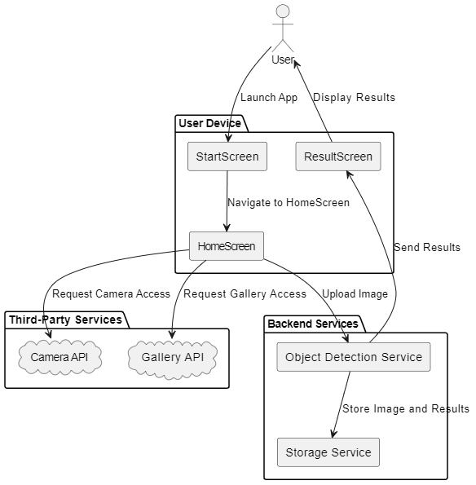

Figure 4.1: System Architecture

The architecture of the Check-Me application is based on a three-tiered multi-layered structure, separating the user interface, business logic, and model logic. This separation ensures that each layer can evolve independently without affecting the others.

4.1.1: Presentation Tier (Mobile Client)
Technology: React Native (JavaScript/TypeScript)
This tier handles all communication with the user and provides access to device features like camera and gallery.

Modules in This Tier:

1. User Interface (UI) Module
- Renders all screens (Home, Camera View, Gallery Picker, Results View).
- Shows processing indicators while detection is performed.
- Displays results in a visually clear annotated format.

2. Input Handling Module
- Integrates with camera hardware through the React Native Camera API.
- Integrates with file storage/gallery pickers to load images.
- Handles permissions and user confirmation prompts.

3. Network Communication Module
- Sends HTTP requests to backend API endpoints.
- Encodes images into Base64 or byte streams.
- Receives JSON responses or annotated images from the server.
- Handles timeouts, failures, and retries.

Relationships
The mobile client:
- Sends image data to the server
- Receives detection results
- Displays results to the user
It is a thin client, delegating heavy computation to the backend.

4.1.2: Application / Business Logic Tier (Backend Server)
Technology: Django Framework + Django REST Framework (Python)
This is the computational and decision-making core of the entire system.

Modules in This Tier:

1. API Gateway / Request Handler
- Exposes secure REST endpoints (POST /detect).
- Validates incoming image payloads.
- Performs input sanitization and transformation.

2. Object Detection Module
- Loads YOLOv8 weights during initialization.
- Runs inference on incoming images.
- Extracts:
- Bounding boxes
- Class labels
- Confidence scores
3. Post-processing / Annotation Module
- Transforms YOLOv8’s tensor output into readable JSON.
- Optionally overlays bounding boxes onto the original image.
- Prepares final results to be returned to the client.

Relationships
The backend:
- Receives requests from mobile client
- Communicates with YOLOv8 model layer
- Sends structured results back

4.1.3: Model Tier (Object Detection Core)
Technology: Ultralytics YOLOv8

Modules in This Tier:

1. YOLOv8 Model Weights
- Contains trained network parameters.
- Stored in .pt format or optimized mobile-compatible formats.

2. Inference Engine
- Uses PyTorch/TensorRT/ONNX to load and run the model.
- Accepts pre-processed images.
- Outputs predictions in raw tensor form.

Relationships
This tier is tightly integrated with the backend, performing the detection task. It is logically separate but physically embedded within the Django server.

3.2.4: Summary of Architectural Approach
The architecture provides:
- Separation of concerns (UI ↔ Logic ↔ Model)
- Better performance (ML kept server-side)
- High maintainability (model upgrades don’t affect UI)
- Scalability (backend can be deployed on powerful servers)
This makes the system suitable for real-world use and future expansion.

4.2: Data Representation [Diagram + Description]

Data representation describes how data is structured, stored, and processed within the system. In the proposed Object Detection Application, data mainly consists of visual information such as images or video frames that are analyzed to detect objects.

The system receives input data from the user in the form of an image file or a live camera feed. This input data is first processed to ensure it is in a suitable format for analysis. The preprocessing stage may include resizing the image, converting color formats, and preparing the data so that it can be used effectively by the object detection algorithm.

After preprocessing, the data is passed to the object detection module, where computer vision and machine learning techniques are applied. The system analyzes the visual features of the image and identifies objects based on patterns learned during the model training phase. Each detected object is represented with specific information such as the object label and its position within the image.

The output data generated by the system includes the detected object labels and bounding box coordinates that indicate the location of the objects in the image or video frame. These results are then displayed to the user through the application interface.
This method of data representation ensures that visual data is processed efficiently and that the detection results are presented in a clear and understandable format for the user.

Diagram + Description

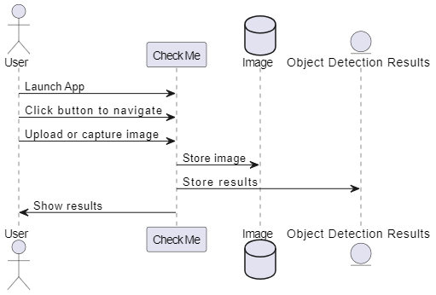

Figure 4.2: Data Representation
The Data Representation Diagram illustrates how data flows between the user and the system components during the object detection process. It shows the interaction between the User, the CheckMe application, the Image storage, and the Object Detection Results module.
The process begins when the user launches the application. After launching the app, the user navigates through the interface by clicking the appropriate button to start the object detection process. The user then uploads an image or captures an image using the camera within the application.
Once the image is provided, the CheckMe application processes the input and stores the image in the image storage component. This step ensures that the input data is properly saved and available for further processing. After the image is stored, the system performs the object detection operation, which analyzes the image using computer vision techniques to identify objects present in it.
Following the detection process, the detection results are generated and stored in the Object Detection Results component. These results typically include information such as the identified objects and their corresponding detection data.
Finally, the system retrieves the processed information and displays the results back to the user through the application interface. The user can then view the detected objects and the output generated by the system.
This diagram demonstrates the flow of data from user input to system processing and final output, highlighting how the application manages image data and detection results in an organized and structured manner.

4.3: Process Flow/Representation

The process flow outlines how the system performs object detection and delivers results to the user. It begins when the user launches the application and starts the detection process by uploading an image or capturing one with the device camera. The system securely stores the image and analyzes it using advanced computer vision and machine learning algorithms to identify objects accurately within the scene.

During the detection process, the system determines the labels, positions, and confidence levels of the detected objects. Once the analysis is complete, the results are generated and presented to the user through the application interface. Detected objects are highlighted with bounding boxes and labels, allowing users to easily interpret, interact with, and understand the information provided by the system.

4.3.1: Level 0

Figure 4.3.1: Process Flow -level 0

4.3.2: Level 1

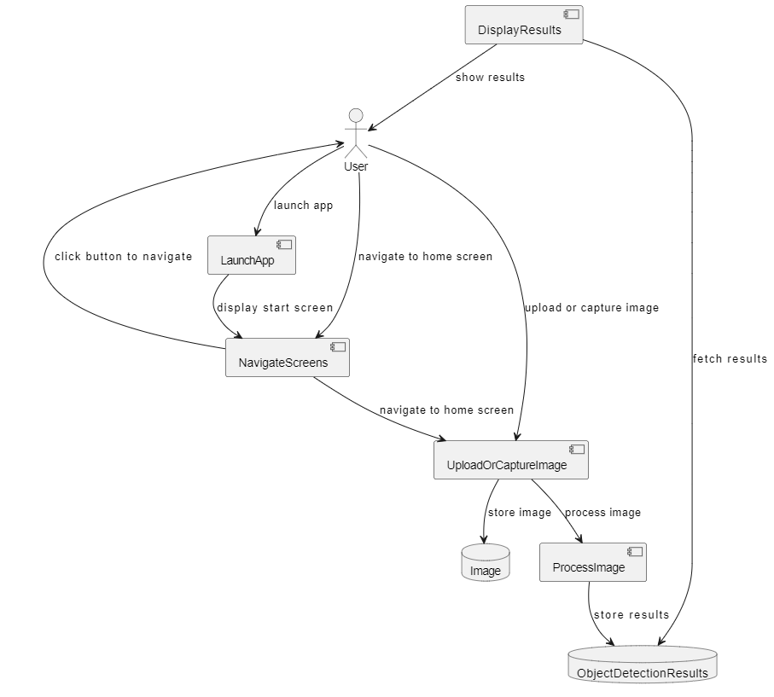

Figure 4.3.2: Process Flow -level 1

4.3.3: Level 2

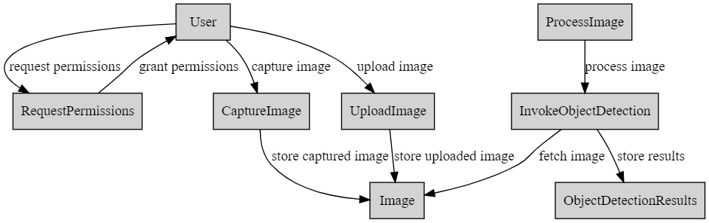

Figure 4.3.2: Process Flow -level 2

4.4: Design Models [along with descriptions]

System design models used to describe, analyze, and validate the internal and external behavior of the Check-Me application. These models provide a visual and conceptual representation of:
- The structural composition of the system
- The dynamic interactions between components
- The transition of states within the application
- The flow of data across different processing layers

Each model contributes to the overall design integrity and ensures that the implementation aligns with the architecture defined in earlier chapters.
Because the system uses an Object-Oriented Design approach, UML modeling techniques—such as Class Diagrams and Sequence Diagrams—are particularly suitable. For data transformation and process flow representation, Data Flow Diagrams (DFDs) give insight into how data moves through the system.

4.4.1: Class Diagram

The Class Diagram models the core logical components and their relationships within the application, particularly on the back-end (Django) and the data representation shared with the client.

Justification:
The system involves clear data entities (Image, DetectionResult, DetectedObject) and functional components (DetectionService, APIController). The Class Diagram provides a blueprint for the object-oriented implementation, showing how these entities are structured and related through associations (composition/aggregation).

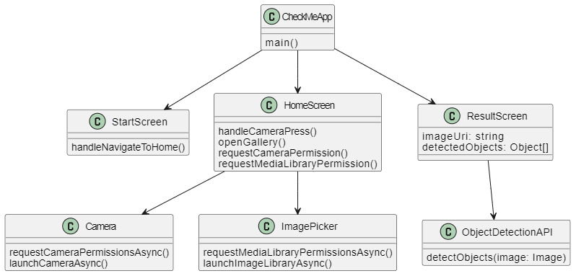

Figure: 4.4.1

4.4.2: Sequence Diagram (Against each use case)

The Sequence Diagram illustrates the temporal order of interactions between the primary actors and objects in the system during the main flow: The Object Detection Process.
Justification:
The process is inherently message-based, involving a clear set of steps (request, processing, and response) across different architectural tiers (Mobile Client and Back-End Server). A Sequence Diagram effectively captures the timing and flow of network communication.

Use case 1: Navigate to the Home-screen

Figure 1

Use Case 2: Take Picture

Figure 2
Use Case 3: Upload Image from Gallery

Figure 3

Use Case 4: View Object Detection Results

Figure 4

Use case 5: Retry object Detection

Figure 5

4.4.3: Flow of Messages:
- User initiates the process by tapping the "Detect" button after capturing/selecting an image.
- Mobile Client calls upload Image (image) on the API Controller. This is the HTTP POST request carrying the image data.
- API Controller validates the request and invokes the core service by calling run Inference (image_data) on the detection Service.
- Detection Service executes the machine learning algorithm (YOLOv8) to identify objects.
- Detection Service returns the raw detection data (bounding boxes, labels) to the API Controller.
- API Controller processes this raw data, creating instances of Detection Result and Detected Object, and serializes the final data into a clean JSON response.

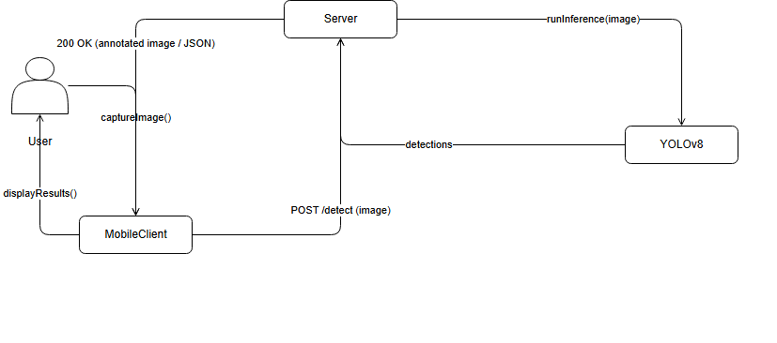

Figure: 4.4.3

4.4.4: State Transition Diagram

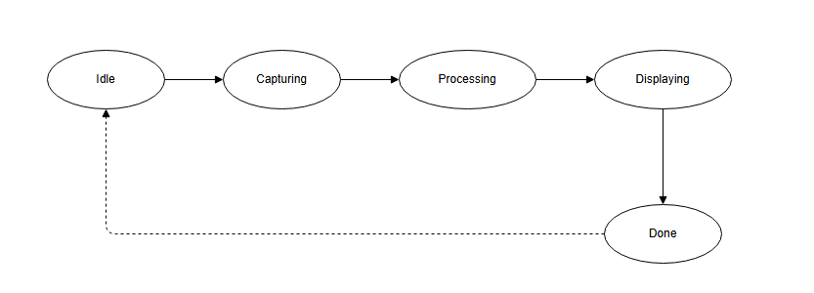

Figure: 4.4.4

4.4.5: Data Flow Diagram

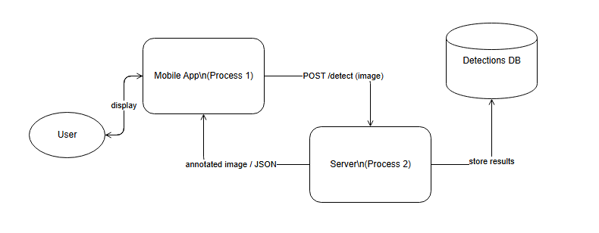

Figure: 4.4.5

4.4.6: Schematic diagram (Hardware projects only)

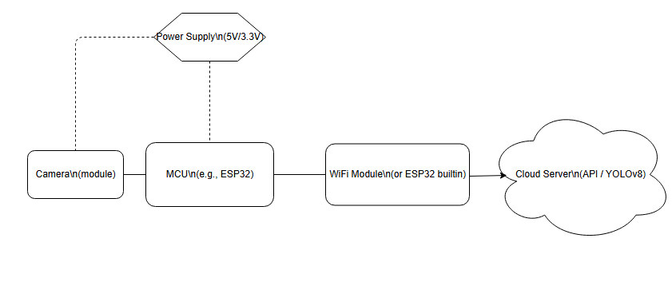

Figure: 4.4.6

4.4.7: Timing diagram (Hardware projects only)

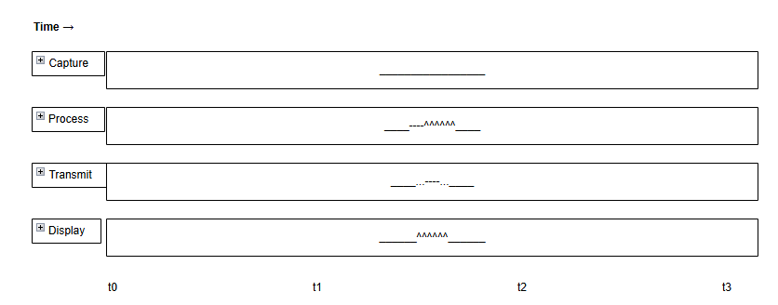

Figure: 4.4.7

5

Implementation

5.1: Algorithm

Code of back End

import os
import logging
from rest_framework.views import APIView
from rest_framework.response import Response
from rest_framework import status
from django.core.files.storage import default_storage
from django.conf import settings
from ultralytics import YOLO
from .serializers import ImageUploadSerializer
import time

# Initialize the logger
logger = logging.getLogger(__name__)

class ObjectDetectionView(APIView):
def post(self, request):
logger.info("Received a request for object detection")

serializer = ImageUploadSerializer(data=request.data)
if serializer.is_valid():
image = serializer.validated_data['image']
logger.info(f"Image received: {image.name}, size: {image.size}")

try:
# Save the uploaded image
timestamp = int(time.time()) # Generate a unique timestamp
image_name = f"{timestamp}_{image.name}"
image_path = os.path.join(default_storage.location, 'uploads', image_name)
with default_storage.open(image_path, 'wb+') as file:
file.write(image.read())
logger.info(f"Image saved to: {image_path}")

# Load YOLOv8 model and perform detection
model = YOLO('yolov8s.pt') # Ensure the model path is correct
results = model.predict(source=image_path) # Perform detection
logger.info(f"Detection results: {results}")

# Assuming you want to save and return an annotated image
output_image_path = os.path.join(default_storage.location, 'uploads', 'annotated_' + image_name)
results[0].save(output_image_path) # Save the annotated image
logger.info(f"Annotated image saved to: {output_image_path}")

# Prepare the response URL
annotated_image_url = os.path.join(settings.MEDIA_URL, 'uploads', 'annotated_' + image_name)

# Extract detected objects
detected_objects = []
for obj in results[0].boxes:
detected_objects.append({
'name': model.names[obj.cls.item()], # Fetching the object name using class id
'confidence': obj.conf.item()
})
logger.info(f"Detected objects: {detected_objects}")

response_data = {
'result_image_url': request.build_absolute_uri(annotated_image_url),
'detected_objects': detected_objects
}

return Response(response_data, status=status.HTTP_200_OK)

except Exception as e:
logger.error(f"Error during object detection: {str(e)}")
return Response({'error': str(e)}, status=status.HTTP_500_INTERNAL_SERVER_ERROR)
else:
logger.error(f"Serializer errors: {serializer.errors}")
return Response(serializer.errors, status=status.HTTP_400_BAD_REQUEST)

logger.info("Object detection completed successfully")
return Response(status=status.HTTP_200_OK)

5.2: External APIs
Name of API | Description of API | Purpose of usage | List down the function/class name in which it is used
TensorFlow  (TensorFlow.js/TensorFlow Lite) | Open-source machine learning framework for building, training, and running ML models. Supports both web and mobile deployment. | Performs object detection using pre-trained models (e.g., COCO-SSD, YOLOv5) or custom-trained models. Handles prediction, bounding box calculation, and object classification. | -tf.loadGraphModel(url) – loads a pre-trained model.  - model.predict(tensor) – performs prediction on input image tensor.  - COCO-SSD / YOLOv5 – pre-trained object detection models.  -tf.browser.fromPixels– converts image to tensor for processing.
React Native | Cross-platform JavaScript framework for building mobile apps for Android and iOS. Provides UI components and access to device hardware (camera, storage). | Handles the app interface, captures images/video for detection, displays results, and manages user interaction. | - Camera (from react-native-camera or expo-camera) – accesses device camera.  - Image – displays uploaded or captured images.  - View – layout container for UI.  - Text – shows labels, confidence scores, or instructions.  - TouchableOpacity – handles button interactions (e.g., capture image).
OpenCV  (OpenCV.js / OpenCV-Python) | Open-source computer vision library for image/video processing, pre-processing, and visualization. | Pre-processes images (resizing, color conversion), draws bounding boxes, overlays labels, and improves detection visualization. | - cv.imread() – reads an image from file or camera stream.  - cv.cvtColor(src, cv.COLOR_RGBA2RGB) – converts image color format.  - cv.resize(src, newSize) – resizes image to required input size.  - cv.rectangle(img, pt1, pt2, color, thickness) – draws bounding boxes around detected objects.  - cv.putText(img, text, org, font, fontScale, color, thickness) – adds labels to objects.  - cv.imshow(canvasId, img) – displays image in browser canvas (OpenCV.js).

Table 5.2

5.3: User Interface

The human interface in Check-Me app is responsible for enabling smooth interaction between the user and the system. It allows users to capture or upload images, initiate the detection process, and view the results in a clear and visually understandable format through labels and bounding boxes. A well-designed interface improves usability, accessibility, and overall user experience.

5.3.1: Screen Images

Screen 1: Splash Screen
- App logo and name displayed in the center.
- Automatically transitions to the Home screen.

Screen 2: Home / Detection Screen
Camera preview area or placeholder panel.
- Two main buttons:
  - Capture Image
  - Upload from Gallery
- A small menu icon for settings (optional).

Screen 3: Processing Screen
- Spinner or progress animation.
- Text indicator: “Detecting objects…”
- A disabled interaction until processing is complete.

Screen 4: Results Screen
- Annotated image with bounding boxes.
- List of detected objects with:
  - Name
  - Confidence score
- Buttons:
  - Save Result
  - Retry Detection
  - Back to Home

Screen 5: History / Logs Screen
- List of saved detection logs.
- Each item shows:
  - Thumbnail of the image
  - Date & time
  - Summary of top detections
- Tap to view detailed results.

5.3.2: Screen objects and actions
Below is a detailed description of each UI element and the associated user actions.

5.3.2.1: Splash Screen
Screen Object | Action | Description
App Logo | None | Displayed briefly when app opens.
Progress/Delay | Auto-navigation | Automatically moves to Home screen after 2–3 seconds.
Figure 1

5.3.2.2: Home / Detection Screen
Screen Object | User Action | System Response
Camera Preview Panel | User views live camera feed | Shows real-time camera input.
Capture Image Button | Tap | Opens camera → captures image → sends for preprocessing.
Upload Image Button | Tap | Opens file picker → user selects gallery image → app sends for detection.
Menu / Settings Icon | Tap | Opens app settings (optional).

Figure 2

5.3.2.3: Processing Screen
Screen Object | User Action | System Response
Loading Animation | None | Shows processing status.
Processing Text | None | Indicates detection is running.

5.3.2.4: Results Screen
Screen Object | User Action | System Response
Annotated Image View | View | Displays image with bounding boxes and labels.
Detected Items List | Scroll | Shows detected object names and confidence values.
Save Button | Tap | Stores image + results in local history/database.
Retry Button | Tap | Returns to detection screen for a new image.
Back Button | Tap | Goes back to Home screen.
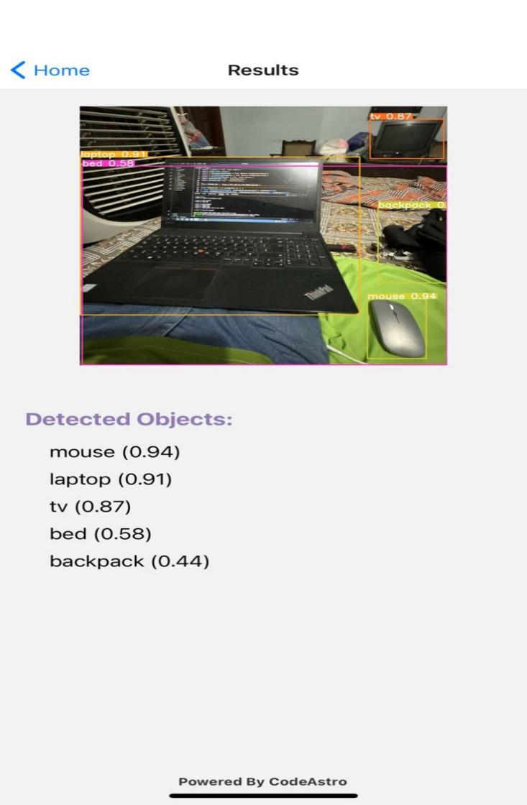

Figure 3

5.3.2.5: History / Logs Screen

Screen Object | User Action | System Response
Log List Items | Tap | Opens previous detection with full details.
Thumbnail Image | Tap | Enlarges image.

6 6

Testing and Evaluation

This chapter presents the testing and evaluation of the object detection system to ensure its functionality, accuracy, and reliability. It focuses on verifying that all components of the application operate correctly, including image input, processing, detection, and result display. Various testing methods are applied to evaluate system performance, usability, and error handling under different conditions.

6.1: Manual Testing

Manual testing was conducted to evaluate the functionality and usability of the object detection application from a user’s perspective. Various test cases were designed and executed to verify core features such as navigation, image capture, image upload, object detection, and error handling. The testing process involved interacting with the application in real-time by simulating user actions like navigating between screens, capturing images through the camera, and uploading images from the gallery.
The results of manual testing showed that all major functionalities of the system performed as expected. The application successfully detected objects, displayed annotated results, and handled user inputs efficiently. Additionally, error handling mechanisms worked effectively by providing appropriate messages when permissions were denied or invalid actions were performed. Overall, manual testing confirmed that the system is reliable, user-friendly, and meets the specified functional requirements.
6.1.1: System Testing

System testing was performed to evaluate the complete and integrated application to ensure that all components function together correctly. It involved testing end-to-end workflows such as navigation, image capture, image upload, object detection, and result display. The system was tested under different scenarios to verify performance, reliability, and error handling. The results confirmed that the application operates smoothly as a whole and meets the defined system requirements.

Test Cases

Test Case 1: TC_001

Test Case Id | TC_001
Test Engineer | Ali
Functional Area | Navigation
Test Name | Verify Navigation to Home Screen
Objective | To verify that the user can navigate from the Start Screen to the Home Screen successfully.
Environment | React Native (Frontend)
Strategy | Launch the app, verify Start Screen is displayed, click on the button to navigate to Home Screen
Expected Result | App navigates to Home Screen without errors.
Test Result | Pass

Test Case 2: TC_002

Test Case Id | TC_002
Test Engineer | Fatima
Functional Area | Image Capture
Test Name | Verify Image Capture from Camera
Objective | To verify that users can capture images using the device's camera for object detection.
Environment | React Native (Frontend), Device Emulator
Strategy | Open app, navigate to Home Screen, click on Camera button, capture an image
Expected Result | Image is successfully captured and ready for processing.
Test Result | Pass

Test Case 3: TC_003

Test Case Id | TC_003
Test Engineer | Ahmad
Functional Area | Image Upload
Test Name | Verify Image Upload from Gallery
Objective | To verify that users can upload images from the device's gallery for object detection.
Environment | React Native (Frontend), Device Emulator
Strategy | Open app, navigate to Home Screen, click on Upload button, select an image from gallery
Expected Result | Image is successfully uploaded and ready for processing.
Test Result | Pass

Test Case 4: TC_004

Test Case Id | TC_004
Test Engineer | Noor
Functional Area | Object Detection
Test Name | Verify Object Detection Results
Objective | To verify that the app displays accurate object detection results on the Result Screen.
Environment | React Native (Frontend), Django (Backend), Object Detection API
Strategy | Upload or capture an image with known objects, verify detected objects and their annotations on Result Screen
Expected Result | Detected objects are accurately displayed with their names below the image.
Test Result | Pass

Test Case 5: TC_005

Test Case Id | TC_005
Test Engineer | Mustafa
Functional Area | Retry Object Detection
Test Name | Verify Navigation Back to Home Screen
Objective | To verify that the user can navigate back to the Home Screen from the Result Screen to perform object detection on a new image.
Environment | React Native (Frontend)
Strategy | Open app, navigate to Result Screen, click on button to return to Home Screen
Expected Result | App navigates back to Home Screen without errors.
Test Result | Pass

Test Case 6: TC_006

Test Case Id | TC_006
Test Engineer | Alina
Functional Area | Error Handling
Test Name | Verify Error Handling for Permissions
Objective | To verify that appropriate error messages are displayed when the user denies camera or gallery access.
Environment | React Native (Frontend)
Strategy | Open app, navigate to Home Screen, attempt to capture or upload image without granting permissions
Expected Result | Error message displayed indicating permission denial.
Test Result | Pass

6.1.2: Unit Testing
  - Test Case WB_Unit_001: Test individual function for capturing images.
    - Steps: Write unit test to directly call captureImage () function.
    - Expected Result: captureImage () function behaves as expected, prepares image for processing.
  - Test Case WB_Unit_002: Unit test for image uploading function.
    - Steps: Write unit test to simulate galleryImageUpload () function call.
    - Expected Result: galleryImageUpload () function correctly uploads image for processing.
  - Test Case WB_Unit_003: Validate object detection function.
    - Steps: Write unit test to directly call objectDetection () function with a known image.
    - Expected Result: objectDetection () function accurately detects objects as per test data.

No. | Test case/Test script | Attribute and value | Expected result | Result
1. | Test individual function for capturing images | Function: captureImage() | Function behaves as expected and prepares image for processing | Pass
2. | Unit test for image  uploading function | Function:  galleryImageUpload()
  Function correctly
  uploads image for
  processing
  Pass
3. | Validate object  detection function | Function:  objectDetection() with known image input | Function accurately  detects objects as per  test data | Pass

6.1.3: Functional Testing
  - Test Case BB_Func_001: Test image capturing using the device's camera.
    - Steps: Ensure camera permission is granted, capture an image.
    - Expected Result: Image is captured and ready for processing.
  - Test Case BB_Func_002: Validate image uploading from the device's gallery.
    - Steps: Ensure gallery permission is granted, upload an image.
    - Expected Result: Image is uploaded successfully and ready for processing.
  - Test Case BB_Func_003: Verify object detection accuracy.
    - Steps: Upload or capture an image known to contain specific objects.
    - Expected Result: Correct objects are detected and annotated accurately on the Result Screen.
  - Test Case BB_Func_004: Ensure smooth navigation back to Home Screen after viewing results.
    - Steps: After viewing results on Result Screen, navigate back to Home Screen.
    - Expected Result: Home Screen is displayed without issues, ready for new actions.

No. | Test case/Test script | Attribute and value | Expected result | Result
1. | Test image capturing using device camera | Permission: Camera granted  Action: Capture image | Image is captured and ready for processing | Pass
2. | Validate image uploading from gallery | Permission: Gallery granted  Action: Upload image
  Image is uploaded
  successfully and ready
  for processing
  Pass
3. | Verify object detection  accuracy | Verify object detection accuracy | Correct objects are detected and annotated accurately on Result Screen | Pass
4. | Correct objects are  detected and annotated  accurately on Result  Screen |  | Home Screen is displayed without issues and ready  for new actions | Pass
  Ensure navigation
  back to Home Screen
6.1.4: Integration Testing

  - Test Case WB_Integration_001: Test integration between frontend and backend modules.
    - Steps: Validate communication between React Native frontend and Django backend.
    - Expected Result: Data is transferred correctly between frontend and backend, functions as expected.
  - Test Case WB_Integration_002: Verify integration of camera API with frontend.
    - Steps: Test communication between React Native frontend and device's camera API.
    - Expected Result: Camera API is accessed and used correctly by the application.

No. | Test case/Test script | Attribute and value | Expected result | Result
1. | Test integration between frontend and backend  modules | Frontend: React Native  Backend: Django | Data is transferred correctly between frontend and backend and functions as expected | Pass
2. | Verify integration of  camera API with  frontend | Component: Camera API  Frontend: React Native | Component: Camera API  Frontend: React Native
  Pass

6.2: Automated Testing:

Automated testing in the system was supported using modern testing frameworks to ensure efficiency and reliability. Tools such as Jest were used for testing the React Native frontend components and application logic, allowing fast and consistent validation of UI behavior. For backend testing, PyTest was utilized to test Django-based APIs and server-side functions, ensuring accurate data processing and communication between modules. These tools helped automate repetitive test cases, improve test coverage, and quickly identify errors, ultimately enhancing the overall quality and stability of the application.

Tools used:

 | Tool Name | Tool Description | Applied on  [list of related test cases / FR /NFR] | Results
 | Jest | JavaScript testing framework used for testing React Native components and  logic | JavaScript testing framework used for testing React Native components and logic | All frontend components tested  successfully with accurate results
 | PyTest | Python-based testing framework for backend and API testing | Python-based testing  framework for backend and  API testing | Backend functions executed correctly and returned  expected outputs
 | Postman | API testing tool used to validate backend services and responses | API testing tool used to  validate backend services  and responses | APIs responded correctly with valid data and status codes
 | GitHub Actions |  | Continuous integration, automated test execution (NFR) | Tests executed automatically with consistent performance
  CI/CD tool for automating build
  and testing processes

7

Conclusion and Future Work

7.1: Conclusion

The CheckMe application successfully achieves its goal of providing an intuitive and efficient platform for object detection using mobile devices. By enabling users to navigate seamlessly from the Start Screen to the Home Screen, the app ensures ease of access to its core functionalities. Users can capture images via the device's camera or upload them from the gallery, with both options integrated smoothly into the app's workflow. The object detection process is handled efficiently, with results displayed clearly, allowing users to view annotated images and detailed object lists. Furthermore, the application effectively manages errors, providing informative messages when permissions are denied or processes fail. This comprehensive approach to user experience and functionality demonstrates the app's potential as a valuable tool for everyday object detection tasks.

7.1.1: Summary
CheckMe is a comprehensive mobile application designed to simplify the task of object detection for users. The app combines intuitive design, seamless navigation, and powerful functionalities to provide an efficient and user-friendly experience. Here’s a detailed look at the core features and functionalities of CheckMe:
- Navigation: The user journey begins with the app launch, where the Start Screen is presented. From there, users can easily navigate to the Home Screen with a single click. This straightforward navigation process ensures that users can quickly access the app's main features without any confusion or delay.
- Image Capture: CheckMe integrates with the device's Camera API, allowing users to capture real-time images directly within the app. This feature is particularly useful for users who need to perform instant object detection. The app handles the process of requesting camera permissions smoothly, ensuring that users can start taking pictures without unnecessary interruptions.
- Image Upload: For users who wish to analyze existing photos, CheckMe offers an option to upload images from the device's gallery. The integration with the Gallery API allows users to easily browse and select images stored on their device. This flexibility ensures that users can work with both new and pre-existing images, catering to a wide range of use cases.
- Object Detection: Once an image is captured or uploaded, CheckMe processes it using advanced object detection algorithms. The app displays the processed image on the Result Screen, with detected objects annotated directly on the image. Additionally, the names of the detected objects are listed below the image, providing a clear and detailed overview of the detection results. This feature ensures that users can quickly and easily understand the contents of their images.

- Retry Mechanism: In case the initial detection attempt fails or if users wish to analyze a different image, CheckMe provides a retry option. This feature allows users to return to the Home Screen and start the process again, ensuring that they can continue their tasks without having to restart the app or navigate through multiple screens.

7.2: Future Work

The current implementation of CheckMe provides a solid foundation for object detection and image processing. However, there are several areas that can be explored and improved in future iterations.
- ChatGPT Integration for Object Information: Enhance CheckMe by integrating ChatGPT to provide detailed information about detected objects. Users can ask questions like "What is this?" and receive responses describing the object, its uses, or related information.
- Voice Output for Detected Objects: Implement a voice feature that audibly identifies detected objects. This feature can be particularly useful for visually impaired users or situations where hands-free operation is essential.
- Real-Time Object Tracking: Enable CheckMe to track objects in real-time as they move within the camera's field of view. This capability can be beneficial in dynamic environments or for monitoring purposes.
- Enhanced Object Recognition Accuracy: Continuously improve object recognition accuracy through machine learning and AI advancements. This can include training the system with more diverse datasets and refining algorithms.
- Augmented Reality (AR) Integration: Explore AR features that overlay information about detected objects onto the camera feed in real-time. This can provide enriched user experiences and additional context about objects.
- Integration with Smart Glasses: Develop compatibility with smart glasses to provide a heads-up display (HUD) that overlays information about detected objects directly in the user's field of vision.
- Advanced Facial Recognition: Extend CheckMe's capabilities to include advanced facial recognition features, such as identifying individuals and providing relevant information or alerts based on recognized faces.
- Integration with Navigation Systems: Collaborate with navigation systems (e.g., GPS apps) to provide augmented guidance based on detected objects, such as landmarks or points of interest.

8

References

Python: Python Software Foundation. (n.d.). Python 3.12 documentation. Retrieved June 20, 2024, fromhttps://docs.python.org/3.12/
Django: Django: Django Software Foundation. (n.d.). Django documentation. Retrieved June 20, 2024, fromhttps://docs.djangoproject.com/en/stable/
React Native: React Native: Facebook. (n.d.). React Native documentation. Retrieved June 20, 2024, from https://reactnative.dev/docs/getting-started
Expo: Expo: Expo. (n.d.). Expo documentation. Retrieved June 20, 2024, from https://docs.expo.dev/
Expo Android-Build: Expo Android Build: Expo. (n.d.). Expo Android Build documentation. Retrieved June 20, 2024, from https://docs.expo.dev/distribution/building-standalone-apps/
Ultralytics: Ultralytics (Python library for Object Detection): Ultralytics. (n.d.). Ultralytics documentation. Retrieved June 20, 2024, from https://ultralytics.com/yolov5
Object-Detection Model: YOLOv8 Model: Ultralytics. (n.d.). YOLOv8 Model documentation. Retrieved June 20, 2024, from https://ultralytics.com/yolov8
IDE: Visual Studio Code: Microsoft. (n.d.). Visual Studio Code documentation. Retrieved June 20, 2024, fromhttps://code.visualstudio.com/docs
UML Diagrams: draw.io: Draw.io. (n.d.). draw.io documentation. Retrieved June 20, 2024, from https://www.diagrams.net/doc/
Metro Bundler: Metro Bundler. (n.d.). Metro Bundler documentation. Retrieved June 20, 2024, from https://facebook.github.io/metro/
Axios: Axios Error Handling: Axios. (n.d.). Handling Errors - Axios documentation. Retrieved June 20, 2024, from https://axios-http.com/docs/handling_errors
OpenCV: OpenCV. (n.d.). OpenCV documentation. Retrieved June 20, 2024, from https://docs.opencv.org
GitHub: Ponnusamy, A. (n.d.). object-detection-opencv. GitHub. Retrieved June 20, 2024, fromhttps://github.com/arunponnusamy/object-detection-opencv
Anaconda: Anaconda, Inc. (n.d.). Anaconda documentation. Retrieved June 20, 2024, from https://docs.anaconda.com/
REST Framework: Django REST Framework. (n.d.). Django REST Framework documentation. Retrieved June 20, 2024, fromhttps://www.django-rest-framework.org/
Logging: Python Software Foundation. (n.d.). Logging - Python documentation. Retrieved June 20, 2024, fromhttps://docs.python.org/3/library/logging.html
Time: Python Software Foundation. (n.d.). Time - Python documentation. Retrieved June 20, 2024, fromhttps://docs.python.org/3/library/time.html
Figma (UI): abdullahwaleed. (n.d.). Check Me UI design in Figma. Retrieved June 20, 2024, from https://www.figma.com/design/98HNXtk4s1l3IulyqyNg7U/Check-Me?node-id=0-1&t=VZnKMd8uWrROdO5T-0
Android Studio (Emulator):
Google. (n.d.). Android Studio documentation. Retrieved June 20, 2024, fromhttps://developer.android.com/studio
Google. (n.d.). Android SDK documentation. Retrieved June 20, 2024, fromhttps://developer.android.com/sdk

